COMP 0560: Artificial Intelligence I
Exam I
Fall 1998

Chapter 1: Introduction to AI

- [10pts] What may be some ethical issues related to AI and its use?

- [10pts] Describe two major periods in the history of AI and explain their significance.

- [5pts] What is the primary difference between symbolic and subsymbolic approaches to AI? Of these two approaches, which do you think is more effective? Explain your answer.

COMP 0560: Artificial Intelligence I
Exam I
Fall 1998

Chapter 2: Agents

- [10pts] Explain the difference between performance measure and a utility function.

- [5pts] Suppose you have the task of designing a surveilance robot. The percepts of your robot are pixels of varying intensity. Your robot is can cruise halls, attack unauthorized persons, and alert law enforcement authorities. Of the types of agents discussed in class, what type of agent would your robot be?

COMP 0560: Artificial Intelligence I
Exam I
Fall 1998

Chapter 3: Uniformed Search

- [10pts] Given a stack of five blocks (numbered 1 through 5) and the task of converting this initial stack into another stack where each block is stacked in ascending order of their number, is it possible for this task to formulated as a search problem? If so, please provide the problem formulation.

- [10pts] Using the Figure below, what order will the nodes be visited using (a) iterative deepening, (b) uniform-cost search.

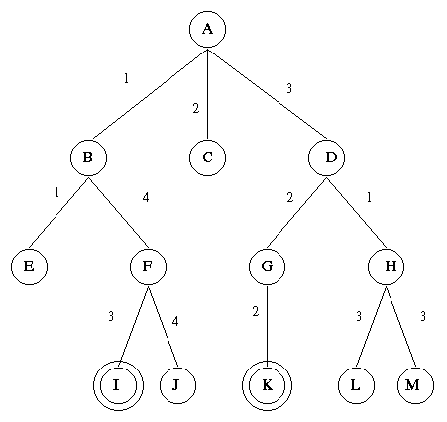

- [10pts] For what type of problems will depth-first search outperform iterative deepening? Illustrate your answer with an example.
COMP 0560: Artificial Intelligence I
Exam I
Fall 1998

Chapter 4: Informed Search

- [15pts] The puzzle below consists of 3 black tiles, 3 white tiles, and 1 empty space. A tile can move into the empty space with a cost of 1. A tile can jump over 1 or 2 tiles into the empty space with a cost equal to the number of tiles jumped. The objective is to move all of the white tiles to the left and all of the black tiles to the right. The position of the empty space is not a concern (in the goal state). Formulate this problem into a heuristic search problem. What type of heuristic would you use? Is it admissible?

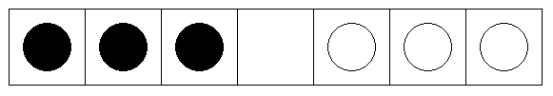

COMP 0560: Artificial Intelligence I
Exam I
Fall 1998

- [15pts] Algorithm A* will not terminate unless a goal node is selected to be expanded. However, it may be the case that a path to a goal node is found long before that goal node is expanded. Why would it not be good idea to terminate search immediately upon discovering a goal node? Illustrate your answer with an example (Hint: Are admissible heuristics always monotonic?).

COMP 0560: Artificial Intelligence I
Exam I
Fall 1998

Extra Credit (Choose 1 of the following)

[5pts] Consider a constraint satisfaction problem (CSP) where X={A, B, C}, D={dA, dB, dC}, dA={a1,a2,a3}, dB={b1,b2,b3}, dC={c1,c2,c3}, and C={C1(A,B}, C2(A,C), C3(B,C)}, C1(A,B)={(a1,b2), (a2,b3), (a3,b1)}, C2(A,C)={(a2,c3),(a2,c1),(a2,c2)}, C3(B,C)={(b2,c3), (b1,c3), (b2,c2)}. Apply arc-consistency then use backtrack search to return the intent of the CSP.

[5pts] Suppose you are able to observe the queue activity of two iterative deepening A* algorithms (IDA*-1 and IDA*-2) solve a problem. Is it possible by merely inspecting the queue activity to determine which of algorithm has the more informed heuristic (for that particular type of problem)? If so, how would one do it? Explain your answer?
COMP 0560: Artificial Intelligence I
Exam I
Fall 1998

COMP 0560: Artificial Intelligence I
Exam I
Fall 1998

